**DATA STRUCTURES LABORATORY**

Roll No. :- [20124107]

BASIC C PROGRAMS (2)

Q.1. Write a C program to check given no. is palindrome or not.

#include<stdio.h>

int main()

{

int n,r,sum=0,temp;

printf("enter the number to find if its palindrome or not \n");

scanf("%d",&n);

temp=n;

while(n>0)

{

r=n%10;

sum=(sum*10)+r;

n=n/10;

}

if(temp==sum)

printf("palindrome number ");

else

printf("not palindrome");

return 0;

}

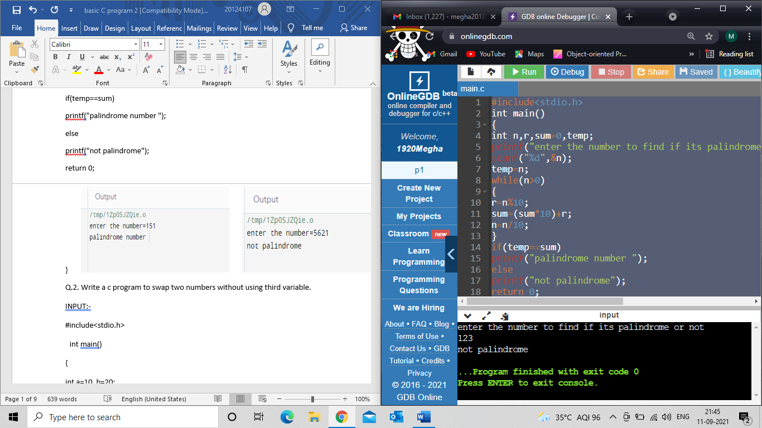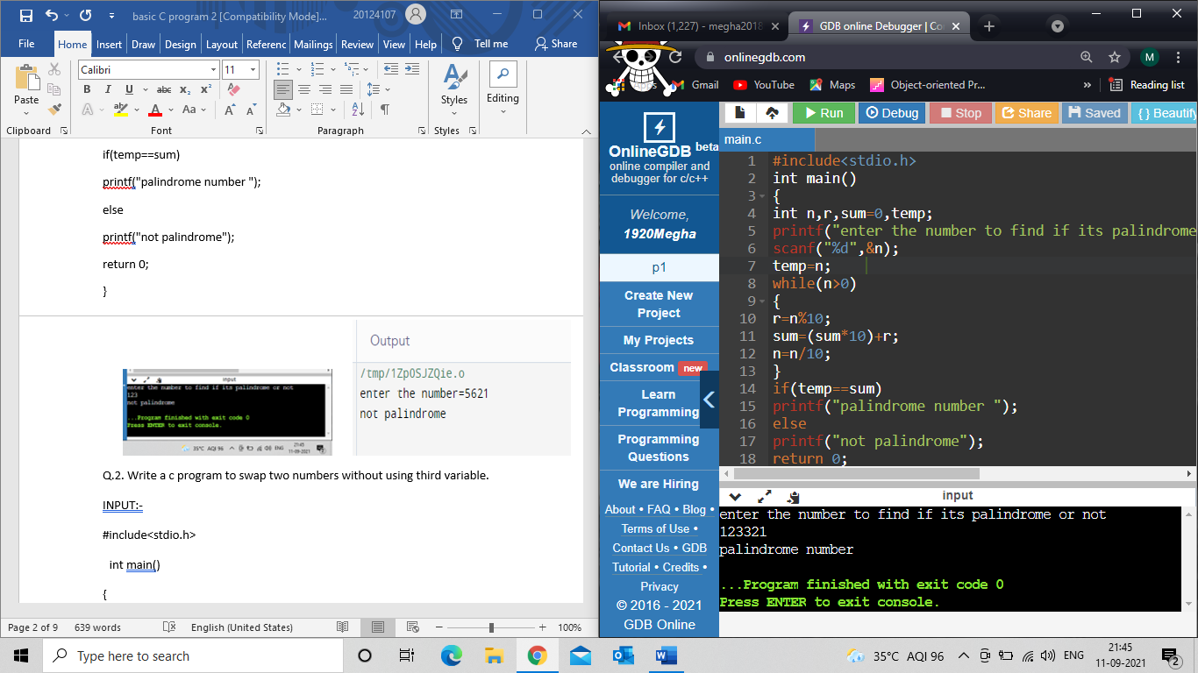

Q.2. Write a c program to swap two numbers without using third variable.

#include<stdio.h>

int main()

{

int a, b;

printf("enter 2 var to swap\n");

scanf("%d \n %d",&a,&b);

printf("Before swap a=%d b=%d",a,b);

a=a+b;

b=a-b;

a=a-b;

printf("\nAfter swap a=%d b=%d",a,b);

return 0;

}

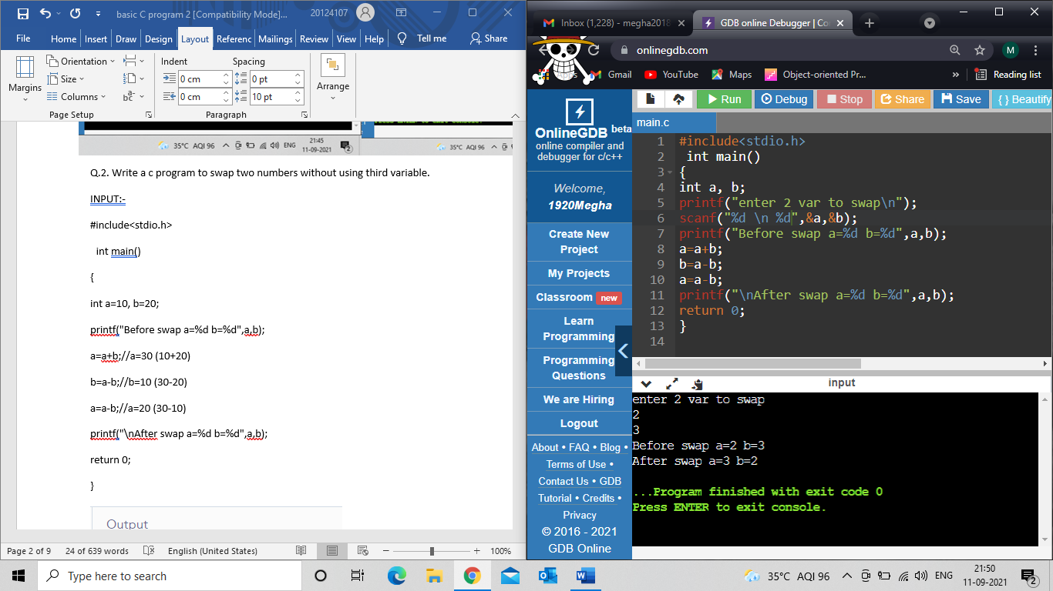

Q.3. Write a c program to convert number in characters.

#include<stdio.h>

int main() {

int n, rev = 0, r;

printf("Enter a number:");

scanf("%d", &n);

while (n > 0) {

r = n % 10;

rev = rev * 10 + r;

n = n / 10;

}

n = rev;

while (n > 0) {

r = n % 10;

switch (r) {

case 0:

printf("Zero ");

break;

case 1:

printf("One ");

break;

case 2:

printf("Two ");

break;

case 3:

printf("Three ");

break;

case 4:

printf("Four ");

break;

case 5:

printf("Five ");

break;

case 6:

printf("Six ");

break;

case 7:

printf("Seven ");

break;

case 8:

printf("Eight ");

break;

case 9:

printf("Nine ");

break;

}

n = n / 10;

}

return 0;

}

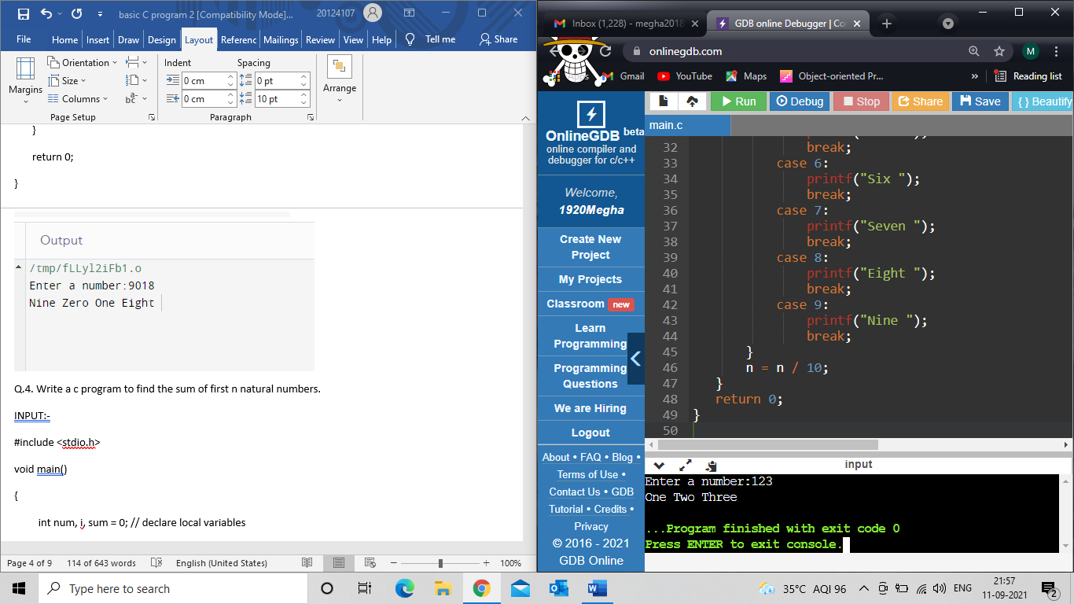

Q.4. Write a c program to find the sum of first n natural numbers.

#include <stdio.h>

void main()

{

int num, i, sum = 0;

printf(" Enter a number : ");

scanf("%d", &num);

for (i = 0; i <= num; i++)

{

sum = sum + i;

}

printf("\n Sum of %d number is: %d", num, sum);

}

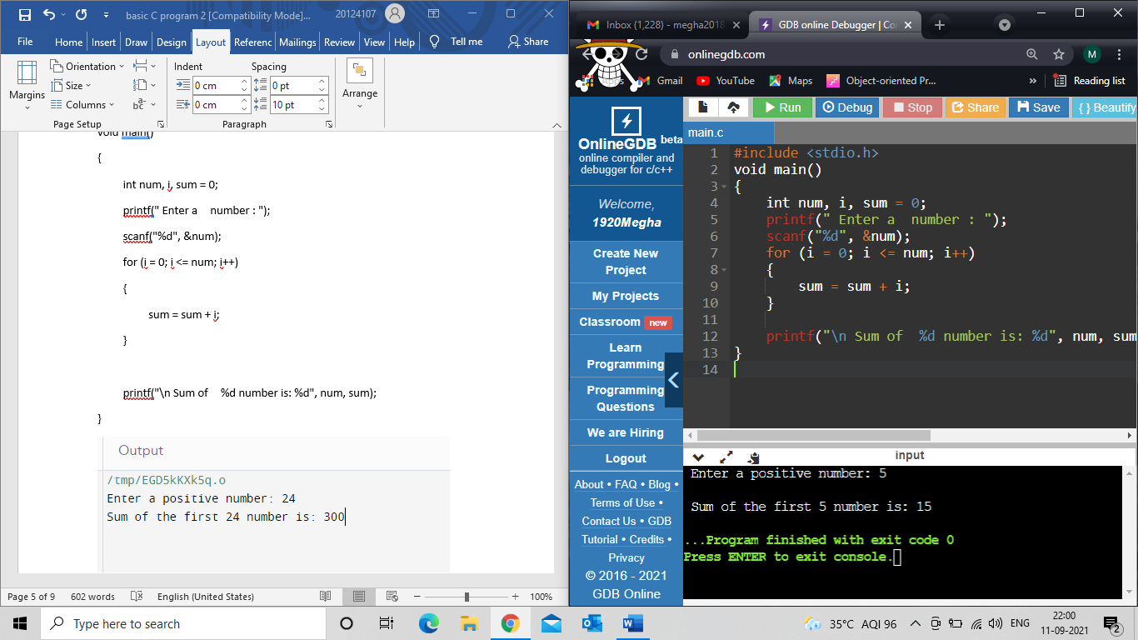

Q.5. Write a c program to check prime and Armstrong number by making

functions.

#include <math.h>

#include <stdio.h>

int checkPrimeNumber(int n);

int checkArmstrongNumber(int n);

int main() {

int n, flag;

printf("Enter a positive integer to check whether it is Armstrong or prime: ");

scanf("%d", &n);

flag = checkPrimeNumber(n);

if (flag == 1)

printf("%d prime number.\n", n);

else

printf("%d is not a prime number.\n", n);

flag = checkArmstrongNumber(n);

if (flag == 1)

printf("%d is Armstrong .", n);

else

printf("%d is not Armstrong .", n);

return 0;

}

int checkPrimeNumber(int n) {

int i, flag = 1, squareRoot;

squareRoot = sqrt(n);

for (i = 2; i <= squareRoot; ++i) {

if (n % i == 0) {

flag = 0;

break;

}

}

return flag;

}

int checkArmstrongNumber(int num) {

int originalNum, remainder, n = 0, flag;

double result = 0.0;

for (originalNum = num; originalNum != 0; ++n) {

originalNum /= 10;

}

for (originalNum = num; originalNum != 0; originalNum /= 10) {

remainder = originalNum % 10;

result += pow(remainder, n);

}

if (round(result) == num)

flag = 1;

else

flag = 0;

return flag;

}}

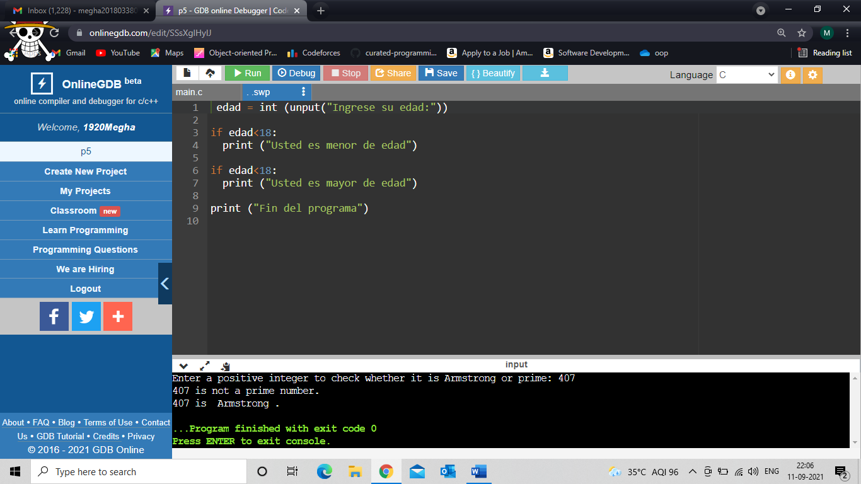

Q.6. Write a c program to find exponential without using pow( ) method.

#include<stdio.h>

int main()

{

int n, exp, exp1;

long long int value = 1;

printf("Enter the number and its exponential:\n");

scanf("%d%d",&n, &exp);

exp1 = exp;

while(exp> 0)

{

value *= n;

exp--;

}

printf("%d^%d = %lld\n\n", n, exp1, value);

return 0;

}

